1. Delete these icons, we don’t need.
2. Mind the Font.
3. These nav buttons are not working properly. Some buttons don’t stay active if clicked on.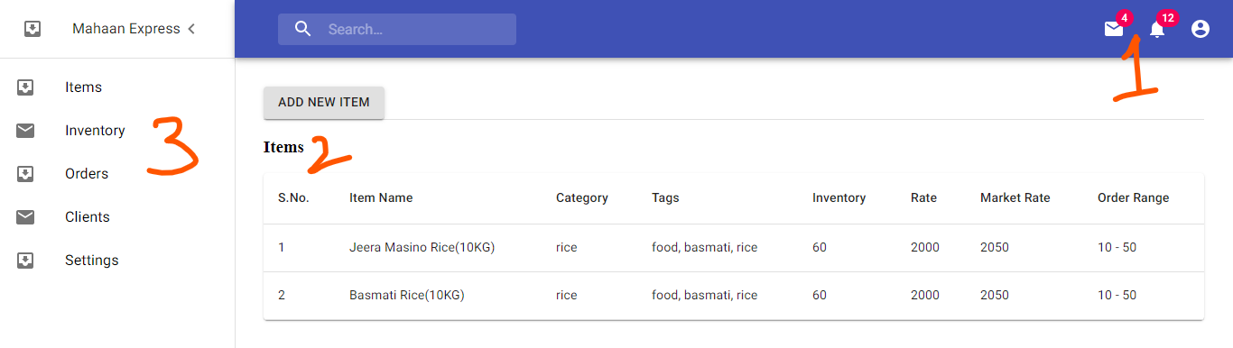
4. Discard FAB… use similar button like above for action. *(FAB on bottom corner looks inappropriate for desktop view, easily lost from sight)*
5. Work on “*Add New Item*” similar with the XD file design… refer to API.docx and *Upload_1.jsx* for image upload. Image files are uploaded at first and the *fileName* is sent from server which is then sent to the add item request on image key.
6. Also, on clicking the table row, display the same Modal for viewing the full data of the specific item with image.
7. While clicking on “*Mahaan Express*” on top left corner button, go to Dashboard.
8. Fix the button size proportion. EITHER just decrease width, height OR use some MD component.  